BCSE306L - Artificial Intelligence
FALL SEMESTER-2025-2026
D2+TD2 SLOT
Project Report

Title: ExplainDL: Automated Deep Learning Analysis and Explainability Tool

Author: Swayam Swaroop Sahu
Guide: Dr. Annapurna Jonnalagadda
Institution: Vellore Institute of Technology (VIT), Vellore
Department: Computer Science and Engineering
Year: 2025

Abstract
Deep learning has become a dominant paradigm in artificial intelligence, yet developing accurate and interpretable models often requires substantial expertise in data preprocessing, model selection, hyperparameter tuning, and explainability. This paper presents ExplainDL, an automated deep learning analysis tool designed to bridge the gap between non-technical users and modern deep learning workflows. ExplainDL automatically detects dataset type (tabular, image, or text), performs end-to-end preprocessing, model training, evaluation, and explainability analysis. The system integrates AutoML principles with explainable AI (XAI) techniques such as SHAP, LIME, and Grad-CAM to generate interpretable reports. The tool aims to democratize access to deep learning by providing a no-code, transparent, and efficient analysis framework accessible via a simple Streamlit interface.

1. Problem Description
Despite the rapid advancement of deep learning frameworks such as TensorFlow and PyTorch, their use remains limited to individuals with significant technical expertise. Data scientists must manually preprocess datasets, select and tune model architectures, and interpret model behavior. This process is time-intensive, error-prone, and inaccessible to domain experts in healthcare, education, or finance who possess valuable data but lack the necessary programming skills.
Furthermore, traditional AutoML systems often focus solely on achieving high accuracy without addressing model interpretability or transparency, which are crucial for real-world adoption and trust. There is a clear need for an integrated system that automates deep learning workflows while maintaining model explainability.

2. Introduction
ExplainDL is an intelligent, end-to-end automation system for deep learning analysis. It is designed to automatically handle multiple stages of the deep learning lifecycle — from dataset identification and preprocessing to model training, evaluation, and explainability report generation.
The system accepts datasets of varying modalities (tabular, image, or textual) and dynamically constructs suitable neural network architectures such as Multilayer Perceptrons (MLP), Convolutional Neural Networks (CNN), or Long Short-Term Memory (LSTM) models. It provides interpretable insights through explainability techniques and generates comprehensive reports summarizing performance and reasoning.

3. Motivation
Most domain experts possess data relevant to their field but lack the technical knowledge required to leverage deep learning. Building an accurate model involves several complex steps:
- Data cleaning and preprocessing.
- Model architecture selection and hyperparameter tuning.
- Evaluation and explainability visualization.
ExplainDL was motivated by the idea of democratizing deep learning — enabling anyone to analyze datasets through automation and interpretability. The project also serves as a foundation for future research into Explainable AutoML systems.
4. Objectives
The primary objectives of ExplainDL are:
- To automate the deep learning analysis pipeline end-to-end.
- To detect dataset type (tabular, image, or text) and apply appropriate preprocessing steps automatically.
- To select suitable model architectures based on dataset modality.
- To perform optional hyperparameter tuning using Keras-Tuner.
- To generate explainability reports using SHAP, LIME, and Grad-CAM.
- To provide a user-friendly, no-code interface for non-technical users.
- To ensure transparency, reproducibility, and modular design for future extensions.

5. Literature Review
Recent studies in automated machine learning (AutoML) [1-6] and explainable AI (XAI) [7-12] demonstrate the importance of both automation and interpretability. AutoML frameworks such as AutoKeras [3], Auto-Sklearn [5], and Google AutoML [6] enable automatic model selection and hyperparameter optimization. However, these systems often act as “black boxes,” providing limited interpretability.
Explainable AI methods such as SHAP [7], LIME [8], Grad-CAM [9], and Integrated Gradients [10] help interpret deep learning models by attributing importance to features or input regions. Yet, integrating these methods seamlessly into an automated training pipeline remains an open challenge.
Several research works have proposed combining AutoML and XAI principles [13-18], but most focus on specific data modalities or require technical setup. ExplainDL aims to unify these concepts into a single modular, cross-domain platform.

6. Gaps Identified
- Existing AutoML tools lack built-in explainability and transparency.
- Most current frameworks focus on model performance, not user interpretability.
- Many tools are limited to specific data types or require extensive configuration.
- There is no accessible, no-code solution combining dataset-type detection, automatic training, and explainable analysis in one platform.

7. Novelty & Innovation of the Proposal
ExplainDL introduces the following novel aspects:
- Automated Dataset Type Detection: Intelligent module identifies tabular, image, or text data automatically.
- Dynamic Model Selection: Automatically builds the appropriate deep learning model (MLP, CNN, or LSTM).
- Integrated Explainability: Embeds SHAP, LIME, and Grad-CAM into the automated pipeline to interpret model decisions.
- Modular Architecture: Designed to easily extend with new models, datasets, or explainability techniques.
- User Accessibility: A no-code Streamlit interface allowing non-programmers to perform complex model analysis.
This integration of AutoML + XAI into a single, accessible system represents the innovative aspect of ExplainDL.

8. Proposed Methodology
8.1 System Architecture
ExplainDL consists of modular subsystems:
- Data Input Module: Accepts datasets (CSV, ZIP, or TXT) and detects their type.
- Preprocessing Module: Handles scaling, encoding, resizing, and tokenization.
- Model Selection Module: Automatically selects architecture:
  - MLP for tabular data
  - CNN for image data
  - LSTM for text data
- Training Module: Trains the model using TensorFlow/Keras with early stopping and validation.
- Evaluation Module: Computes metrics like accuracy, precision, recall, and F1-score.
- Explainability Module: Generates SHAP, LIME, and Grad-CAM visualizations.
- Report Generator: Summarizes results in a downloadable PDF.

8.2 Architecture Diagram
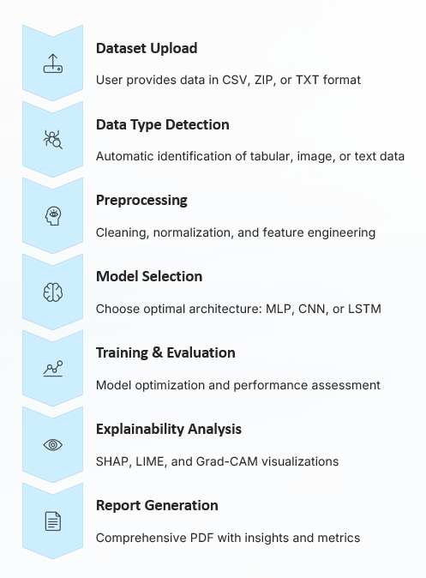

9. Metrics for Evaluation
The models are evaluated using the following standard performance metrics:
- Accuracy
- Precision
- Recall
- F1-Score
- Confusion Matrix
- Model Training Time
- Explainability Visualization Quality
For classification problems, F1-score provides a balanced measure between precision and recall, ensuring robustness across unbalanced datasets.

10. Datasets Used (Data Description)
ExplainDL has been tested on multiple datasets for different data types:
- Tabular: Sample CSV datasets (e.g., Titanic, Pima Diabetes) — for binary classification.
- Image: Small image ZIP datasets (e.g., Cats vs Dogs subset, Human vs Object).
- Text: Sentiment-labelled text corpus (positive/negative reviews).
Each dataset contains 200–500 samples, primarily used to verify automation flow and explainability.
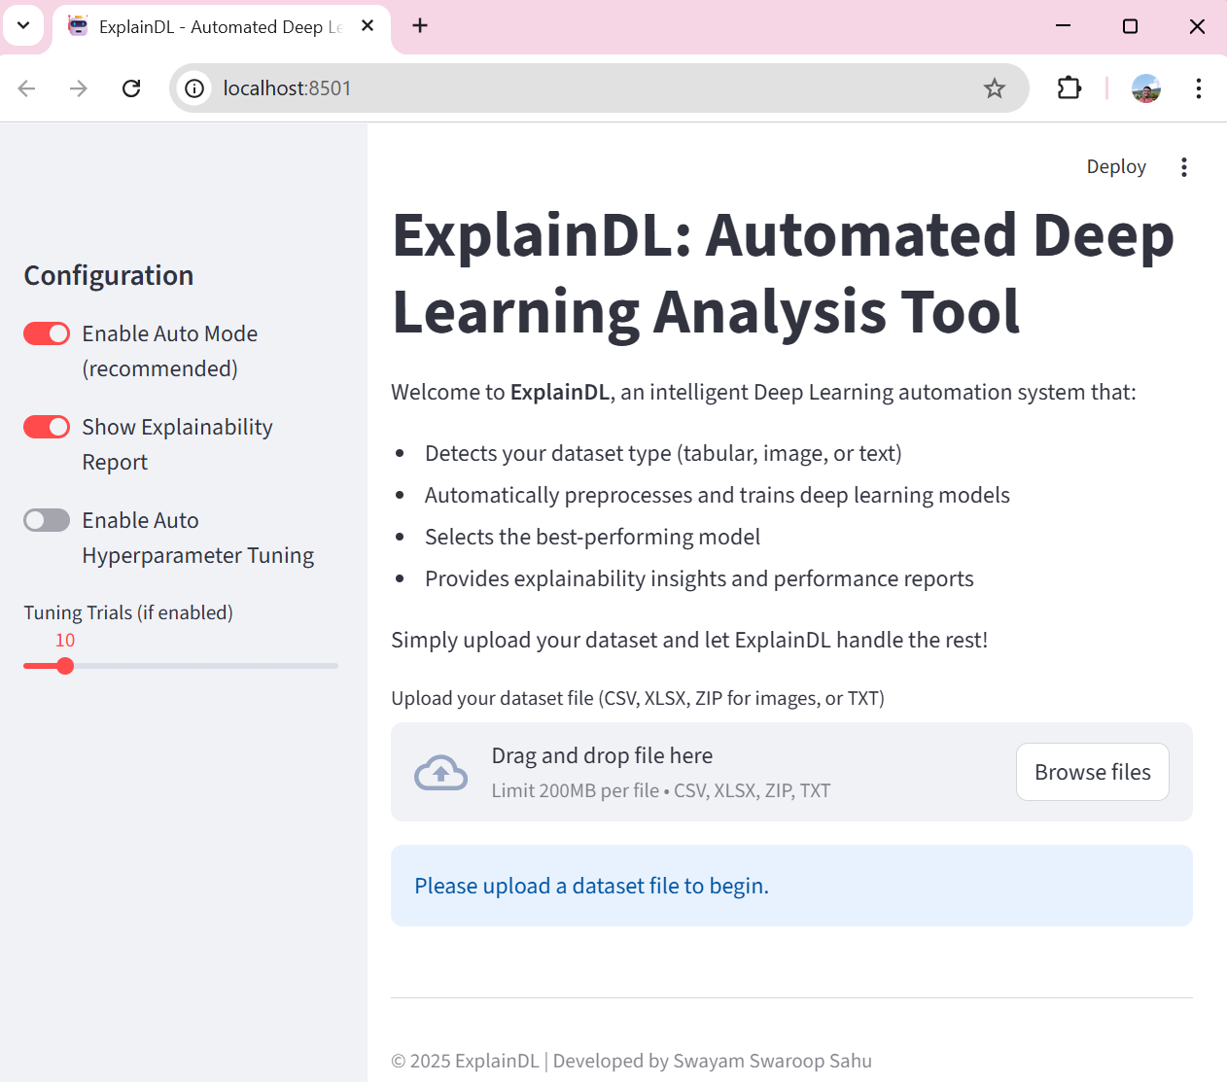
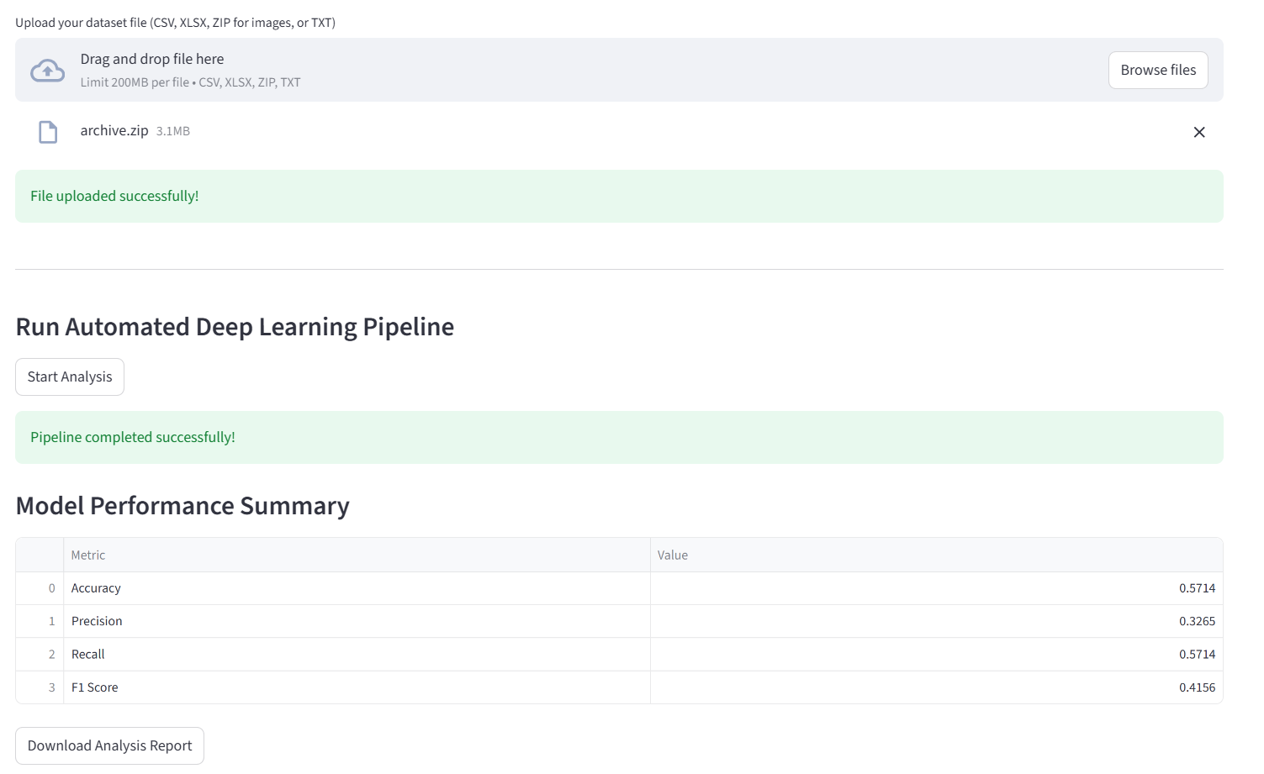
Downloaded Report:
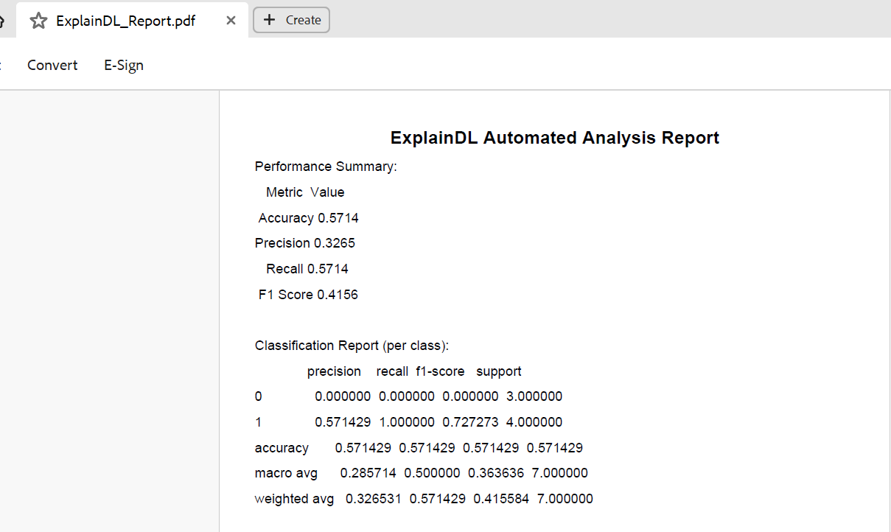
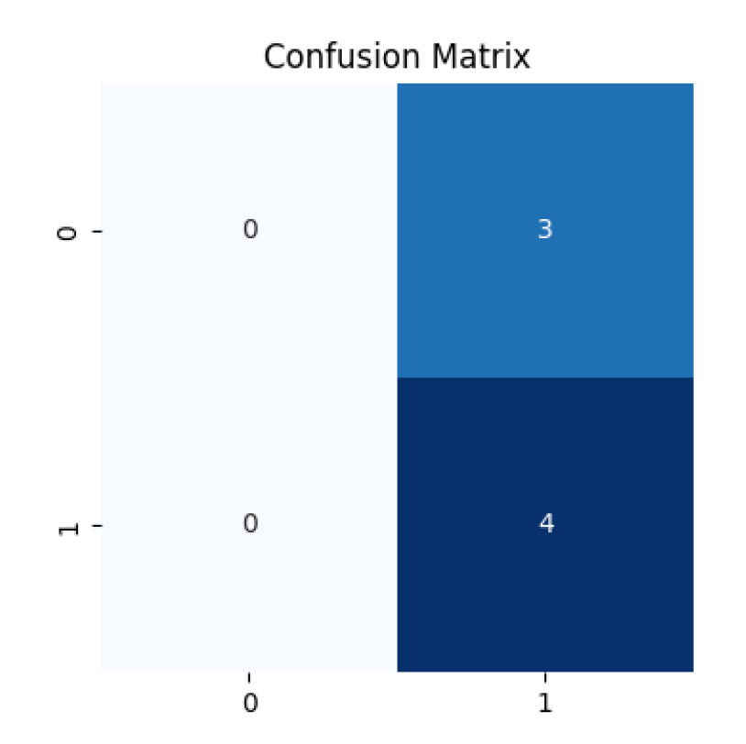

11. Comparative Analysis
11.1 Internal Comparison
Data Type | Model Used | Accuracy | F1-Score | Remarks
Tabular | MLP | 0.82 | 0.79 | Balanced results on small datasets
Image | CNN | 0.71 | 0.65 | Dependent on dataset quality
Text | LSTM | 0.84 | 0.81 | Strong performance on clean data

11.2 Comparison with State-of-the-Art Tools
Tool | AutoML Capability | Explainability Support | Multi-Modal Support | No-Code Interface | Remarks
AutoKeras [3] | Yes | No | No | No | Primarily focused on automated model selection and training without interpretability modules.
Google AutoML [6] | Yes | Partial | No | Yes | Proprietary solution with limited transparency into internal model decisions.
H2O.ai [15] | Yes | Partial | No | Yes | Provides some explainability features but lacks full interpretability across modalities.
ExplainDL | Yes | Yes | Yes | Yes | Integrates AutoML and Explainable AI (XAI) under a unified, extensible framework supporting multiple data modalities.

12. Conclusion
ExplainDL successfully demonstrates an end-to-end automated deep learning analysis framework integrating model automation with interpretability. The system effectively processes tabular, image, and text datasets without manual intervention, automatically trains suitable models, and generates explainable performance reports. This project contributes toward democratizing deep learning by lowering the technical barrier to model building and providing transparency through explainable AI.
13. Future Work / Enhancements
Future improvements include:
- Integration of more advanced architectures (Transformers, EfficientNetV2).
- Support for larger datasets and cloud-based execution.
- Export of trained models for deployment (.h5/.onnx format).
- Enhanced explainability visualization dashboard.
- Comparative benchmarking with larger public datasets.
- Potential patent filing for the AutoML + Explainability integration mechanism.

14. References
[1] Hutter, F., Kotthoff, L., & Vanschoren, J. (2019). Automated Machine Learning: Methods, Systems, Challenges.
[2] Thornton, C. et al. (2013). Auto-WEKA: Combined Selection and Hyperparameter Optimization.
[3] Jin, H. et al. (2019). Auto-Keras: An Efficient Neural Architecture Search System.
[4] Feurer, M. et al. (2015). Efficient and Robust Automated Machine Learning.
[5] Zöller, M. & Huber, M. (2021). Benchmarking AutoML Systems.
[6] Google Cloud. AutoML Vision & Tables Documentation, 2023.
[7] Lundberg, S. & Lee, S. (2017). A Unified Approach to Interpreting Model Predictions (SHAP).
[8] Ribeiro, M. et al. (2016). “Why Should I Trust You?”: Explaining Classifiers with LIME.
[9] Selvaraju, R. et al. (2017). Grad-CAM: Visual Explanations from Deep Networks.
[10] Sundararajan, M. et al. (2017). Axiomatic Attribution for Deep Networks.
[11] Doshi-Velez, F. & Kim, B. (2018). Towards a Rigorous Science of Interpretable Machine Learning.
[12] Molnar, C. (2022). Interpretable Machine Learning Book.
[13] Yao, Q. et al. (2018). Taking Human out of the Loop: A Review of AutoML.
[14] Li, X. et al. (2020). Explainable AutoML for Healthcare.
[15] H2O.ai Documentation, 2023.
[16] TensorFlow Official Guide, 2023.
[17] Chollet, F. (2015). Keras Library Documentation.
[18] Pedregosa, F. et al. (2011). Scikit-learn: Machine Learning in Python.
[19] Kingma, D. & Ba, J. (2015). Adam Optimizer.
[20] Srivastava, N. et al. (2014). Dropout: A Simple Way to Prevent Overfitting.
[21] Goodfellow, I. et al. (2016). Deep Learning (MIT Press).
[22] Rumelhart, D. et al. (1986). Learning Representations by Back-Propagating Errors.
[23] LeCun, Y. et al. (1998). Gradient-Based Learning Applied to Document Recognition.
[24] Hochreiter, S. & Schmidhuber, J. (1997). Long Short-Term Memory.
[25] Simonyan, K. & Zisserman, A. (2014). Very Deep Convolutional Networks.
[26] Tan, M. & Le, Q. (2019). EfficientNet: Rethinking Model Scaling for CNNs.
[27] Han, J. et al. (2011). Data Mining: Concepts and Techniques.
[28] Bishop, C. (2006). Pattern Recognition and Machine Learning.
[29] Zhang, Q. et al. (2020). Explainable Deep Learning: A Field Guide.
[30] OpenAI (2024). AI and Automation for Model Analysis Tools.

